Name of Customer : Mrs.Padma Rani Kammari
Date of Report : 29 Aug, 2025
Application ID 102760000000843
Name of Concern : Chiranjeeva Excavation and Infrastructure Private
Limited
Initiated Address : Viila no 7 cyber meadows society , near chirec public
school ,Kondapur ,dist 500084

Visited Address : Viila no 17 cyber meadows society, near chirec public
school ,Kondapur ,Hyderabad 500084(As per name board address)
Phone : 7382058555/9866667455
Appointment Fixed : 14:04 Date of Visit: 25 Aug, 2025
Structure of Loan : Rs.300lakhs approx.
No. of Visit : 1st visit
Person Met : Mrs.Padma rani Kammari -Applicant Self.
Ms.Hasini(Applicant’s daughter)
Visited By : E.Praveen
Checked By : Nandesu Sapata

About Applicant:
Mr.Padma rani Kammari (Age-54 Years) she is Managing Director of the M/S Chiranjeeva Excavation And Infrastructure Private Limited Since 26/09/2008 She has Total 17 Years Working experience in the Same business line.Earlier, her spouse was one of the Director in this company and after her spouse, applicant’s daughter Ms.Hasini enters in this company since the year 2021.Now total operations done by Ms.Hasini.
Residential Details:
Applicant Resides in his Own Residencial Premises Located at Viila no 17 Cyber Meadows Society Near Chirec Public School Kondapur Hyderabad Telangana Having a area of 3800sq feet Present Market Value Rs 8 Cr Approx.

Co-Applicant Details:
Not provided

Family Details:

Name | Relation with Applicant | Age (Yrs) | Qualification | Occupation | Income per month  (approx.) | Dependent
Ms.Hasini | Daughter | Not Applicable | Architecture | Director in this  company | As per report | InDependent

Constitution: Private Limited Co.
Shareholding Details:

Name of the Shareholder | Relation with  Main Applicant | Designation | % of Shareholding | Coming into Loan Structure | Functional of  Partner / Director
Mrs.Padma rani Kammari | Self | Managing Director since  26/09/2008 | 50 | Yes | All
Mrs. Hasini | Daughter | Director since  12/03/2020 | 50 | No | All
About the Business:
Applicant Operates this business from Owned Residential Cum Business Premises Located at Viila no 17 Cyber Meadows Society Near Chirec Public School Kondapur Hyderabad Telangana Having an area of 3800sq feet Present Market Value Rs 8 Cr Approx. No separate premise demarcated for office.
Chiranjeeva Excavation And Infrastructure Private Limited's Corporate Identification Number (CIN) is U70102TG2008PTC061223 and its registration number is 61223. Incorporated on 26 Dec 2008.
Under this company, Applicant is engaged in the business of Excavation work. They have tie up with some builders and this company’s main role is to take contract from his clients for underground work like digging of earth before construction of buildings and removing of soil, rocks, rock cutting etc. They also does stone blasting, stone breaking work and dumping these different size stones in a certain location of his clients. They have some regular clients in this business and from them this company gets work orders. His main clients are Vessella Aggregates & Aadeswara Aggregates pvt ltd etc located at Kokapet Nallagandla Gachibowli Hyderabad Locations. Her Recipets Transactions from the customers 70% Online and 30% Cash basis With 30 Days of Credit Period. This company raises bills on every month basis depend upon work in progress. They have owned 5 breakers and 2 Bucket machines and she hires 5 machines and pays around of 15% to 20% of total project value. Through those machinery and depend upon requirement hires from outside. Her Payments Transaction to the Suppliers 100% online basis with 30 Days of Credit Period. As per applicant, currently they have 2 working sites located at Kokapet and no any work orders and invoices provided for those sites.
Currently this company having an upcoming work order and already submitted quotation with total value of Rs.21.47Cr approx. and client name MLCP food court

and Quotation negotiation process is going on and this project might be start from Nov-2025.
The approx. rates of some products / services are mentioned below,

Details of Some Products / Services | Product / Service Price Range approx.
Not provided | Not provided


Financial Comparison & Status:

Particulars | A.Y. 2024-25 | A.Y. 2023-24 | Remarks
Annual Receipts | Rs 3,03,28,380/- | Rs 3,03,67,839/- | Decreased
Gross Profit | -- | - | -
Gross Profit Margin | - | - | -
Net Profit | Rs 9,15,748/- | Rs 9,13,663/- | Increased
Net Profit Margin | 3.02% | 3% | Equal
Filled Date | 06/10/2024 | 30/12/2023 | -

Documents Observed:

Document Category | Document Name | Document Type | Remarks
KYC Documents | AADHAAR Card | Original | Verified Found Correct
KYC Documents | PAN Card | Original | BBTPK2046R DOB:17/07/1971
KYC Documents | PAN Card | Original | Company PAN No:AADCC4971G DOB:26/09/2008
Business Constitution Documents | Certificate of Incorporation | Original | Corporate Identity Number:U70102AP2008PTC061223 DOF:26/09/2008
Business Ownership Documents | GST Certificate | Original | GST Certificate Regno:36AADCC4971G2ZL  Date of issue:01/07/2017 (With Different Address)  Kadiri Apuroopa Urban, Flat No 602, Near Chirek International School, Masidbanda, Kondapur, Hyderabad, Hyderabad,  Telangana, 500084
Income & Expense Records | ITRs | Original | AY2024-25 Total Gross Sales Rs 3,03,28,380/- With Net Profit Rs  9,15,748/- DOF:06/10/2024
Income & Expense Records | ITRs | Original | AY2023-24 Total Gross Sales Rs 3,03,67,839/-With Net Profit Rs 9,13,663/-  DOF:30/12/2023
Income & Expense Records | GST Returns | Original | GST returns for last 11 months Apr-2024 to Mar-2025(Except Nov-  2024)
Income & Expense  Records | Bank Statements | Original | Axis Bank C/A Bank Statement  from 01/04/2024 to 31/03/2025
Income & Expense Records | Work orders(old) | Scan images | Work order for stone breaking - issued on 17/09/2018 (No amount mentioned)  Work order for stone breaking - issued on 01/07/2024 (No amount  mentioned)

Work order for stone breaking- issued on 01/08/2022 (No amount mentioned)
Work order for July-2020 and one tax invoice showed

Suppliers/Creditors:

No of Fixed Suppliers : Not provided
Credit Period : 30 days of Credit Period
Cash-Cheque Proportion : 100% Online basis

Name (top 3 Suppliers) | Contact Details | Location | Ref. Check
Not Provided | Not Applicable | Not Applicable | Not Applicable

Clients/Debtors:
No of Fixed Customers 10
Credit Period : 30 days of Credit Period
Cash-Cheque Proportion : 70% Online and 30% Cash basis

Name (top 3 Customers) | Contact Details | Location | Ref. Check
Vessella Aggregates & | Not provided | Hyderabad | Not provided
Aadeswara Aggregates  pvt ltd | Not provided | Hyderabad | Not provided

Average Stock Maintained:
Not Applicable

Turnover & Margins:
As estimated, this company annual turnover is around of Rs.370lakhs to Rs.375lakhs approx. with net profit margin of 9% to 10% approx.

Expenditure:
Salaries & Wages:

No. of  Employees | Salary per  month | Status of  Employee | No. of Labours | Wages per  month / per day | Status of  Labour
70 | Rs 10Lacs | Fixed | Not Applicable | Not Applicable | Fixed
Note: Amounts mentioned above are approx.

Working Hours:

Working Hour's was not fixed.

Other Major Exp. & Basis:
Not Applicable

Asset Details:
All Immovable properties held that is Residential, Commercial, Land, Plot and any fixed structure:
Address | Area Measurements | Purchase  Cost (in Lakhs) | Purchase Year | Market  Value (in Lakhs) | Owner Name | Mortgaged
Villa No 17 Cyber Meadows Society Near Chirec Public School  Kondapur Hyderabad | 3800sq Feet | NP | NP | 800 | Applicant Self | No
Any Liquid, Moveable & Monetary items such as Cash, Gold, FD, RD, Mutual Fund Holdings, Shares, Bonds,  Securities - |  |  | Not provided
Life Insurance, Mediclaim, Property/Asset Insurance  (Premium & Sum Assured) - |  |  | Not provided
Capital invested in any business, Loans & Advances  given - |  |  | Not provided
Car, Bike and any other vehicle (Company Name and  Model) - |  |  | Not provided
Note: Amounts mentioned above are approx.

Loan Details:

Name of Bank  / NBFC | Type of Loan | Sanctione d Amount (in Lakhs) | O/S Balance (in  Lakhs) | EMI (in Rs.) | Tenure (months) | Month on Books (MOB) | EMI Paid Bank | Secured Against which  Asset
No loans on this compan  y | Not Applicabl e | Not Applicabl e | Not Applicabl e | Not Applicabl e | Not Applicabl e | Not Applicabl e | Not Applicabl e | Not Applicabl e
Note: Amounts mentioned above are approx.

Bank Details:

Bank Name | Branch Name | Account Type | Open Since (Year)
IDBI | Kondapur | Current A/C | 4
Axisbank | Financial District | Current A/C | 4

End Use of Loan: (Loan Amount & Detailed End-Use)
Loan Required Amount Rs 3 Cr Approx. for working capital purpose.

Details of Security Offered:
Address:
Villa No 19 Cyber Meadows Society Near Chirec Public School Kondapur Hyderabad

Area Measurements | Agreement Value (in Lakhs) | Actual Purchase Cost (in  Lakhs) | Market Value (in Lakhs) | OCR (in Lakhs) | OCR paid till date (in Lakhs) | OCR Source
3800sq Feet | Not  Applicable | Not  Applicable | 800 | Not  Applicable | Not  Applicable | Not  Applicable


Third Party Check:

Individual /  Business Name | Address | Contact No | Knowing Since | Feedback on  Borrower | Feedback on  Business
Individual | Same  Surrounding Locations | Not Applicable | 2 Years | Positive | Positive

Observation:
- Under this company, Applicant is engaged in the business of Excavation work.
- RCO set up seen and no separate premise demarcated for office in this premise.
- Company Business Name Board was seen during the visit She showed KYC Documents, GST Registration certificate with different address, GSTR3B for last 11 months, 2 Years company ITRs with financials, 1 Year Bank Statement, during the visit.
- TPC was positive About the Applicant and his company.
- Applicant has shown few work orders of 2018,2019,2020,2022 and one work order of 2024, however there is no any work order value mentioned in these work orders.
- This is the private limited company with 2 Directors having equal shares.
- Applicant and her daughter met in this initiated address and all details provided by both during the visit.
- Applicant showed a quotation with total value of Rs.21.47Cr approx. and client name MLCP food court and Quotation negotiation process is going on and this project might be start from Nov-2025.
- Banker provided IDBI CA bank statement and as per applicant, 70% to 80% amount reflected in this account and rest of 20% to 30% she received on cash basis and does not maintain any cash receipts related records. She utilize that cash amount for payment of labors and salaries.

Other Income: (Income from other than initiated business)

Income | Details | Reference
NP | Not Applicable | Not Applicable

Site Images: Enclosed
Site Coordinates: Latitude: 17.4685918, Longitude: 78.3453547

Remarks:
- No any office set up and office activity seen in this premise and as per applicant, her total operation done from client’s site.

- Provided one work order of 2024 but no any amount mentioned there. Showed other work orders belongs to before the year 2020.
- Banker initiated address is Viila no 7 cyber meadows society , near chirec public school ,Kondapur ,dist 500084 however as per applicant and observed name board shows Viila no 17 cyber meadows society Kondapur ,Hyderabad 500084.
- As per provided GST registration certificate shows different address i.e. Kadiri Apuroopa Urban, Flat No 602, Near Chirek International School, Masidbanda, Kondapur, Hyderabad, Hyderabad, Telangana, 500084 however actual RCO address is Viila no 17 cyber meadows society Kondapur ,Hyderabad 500084 and she was not provided current premise business ownership proof for verification purpose.
- As per provided GSTR3B, this company annual turnover is not more than ITR for AY2024-25 financials.
- As per applicant she has no any loan obligations on her name and this company name.
- She was not provided latest period share holding pattern during the visit.
- Depreciation Tangible Assets considered as Nil, and same confirmed with banker.

Financial statement being estimated on the basis of availability of information, setup observation, business calculations, provided Banking, GST returns, and location of operation, Verbal information, and vintage of business, types of industry & TPC Subject to verification of above-mentioned concern in the report.

Status: Positive & Estimated (Subject to above concerns)


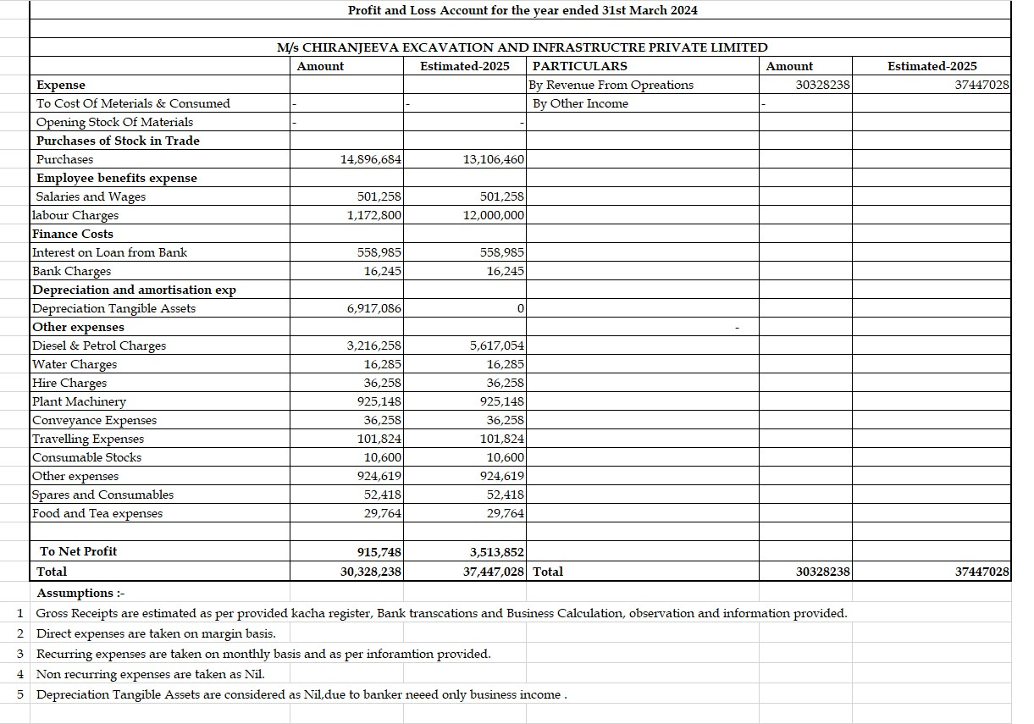
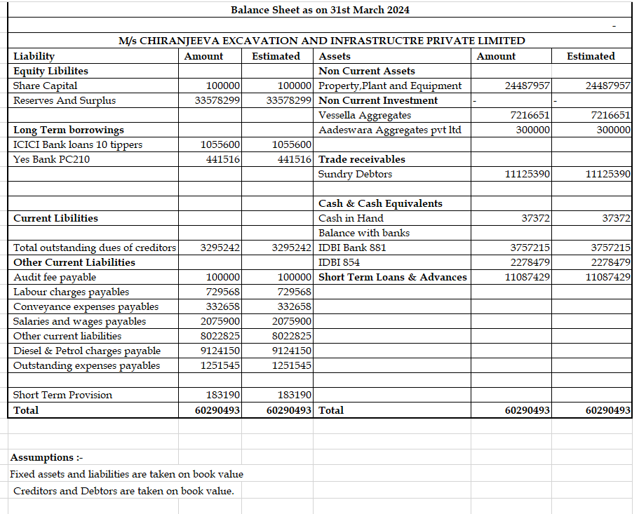


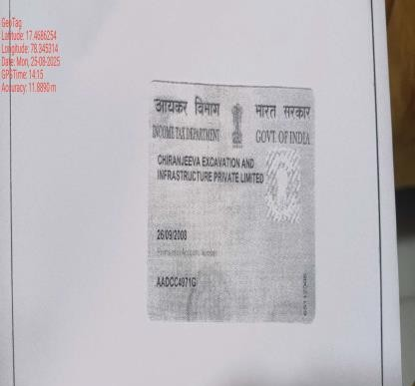
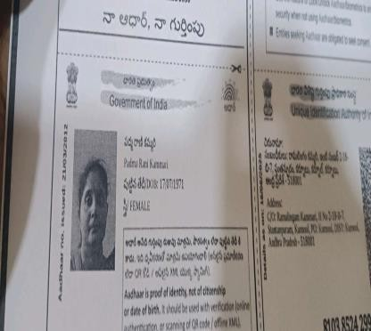
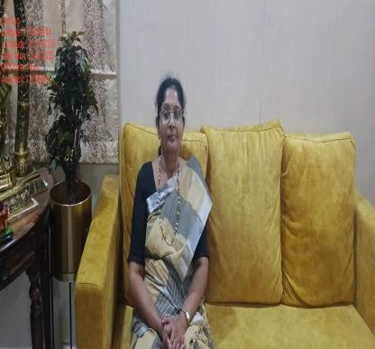
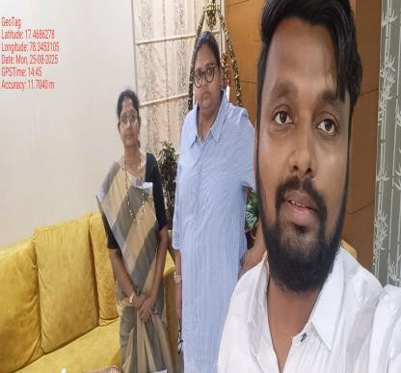
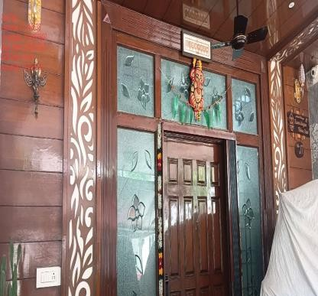
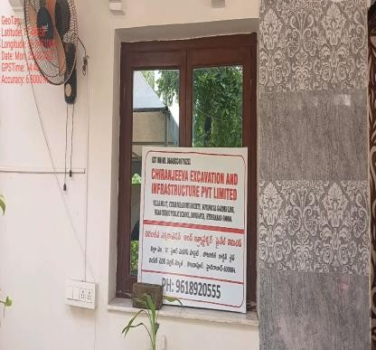
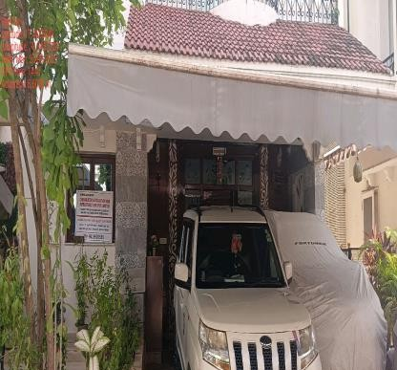
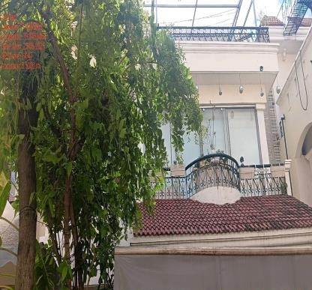
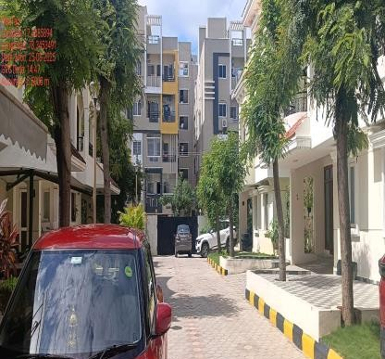
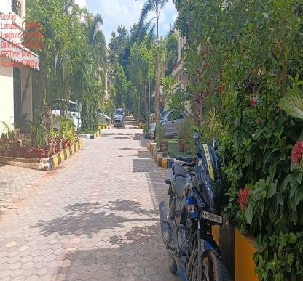


Photographs:

Disclaimer:



This report (including any attachments) has been prepared on the basis of information provided by the person contacted. Jana Small Finance Bank Ltd. will be solely responsible for any actions taken on this report and any liabilities directly or indirectly accruing from such actions. Veeraraghavan & Co. will not be held liable in any case.

